0TITLE 

Department of Information Technology

COLLEGE OF ENGINEERING

CENTRAL LUZON STATE UNIVERSITY

Science City of Muñoz, Nueva Ecija

CLIRDEC: PRESENCE – PROXIMITY AND RFID- ENABLED SMART ENTRY FOR NOTATION OF CLASSROOM ENGAGEMENT

A Capstone Project

Presented to the

Department of Information Technology

In Partial Fulfillment

of the Requirements for the Degree

BACHELOR OF SCIENCE IN INFORMATION TECHNOLOGY

By:

Feria, Matt Calgae S.

July 2025

DISCLAIMER

“This Capstone Project is submitted to the Department of Information Technology, College of Engineering, in partial fulfillment of the requirements for the degree Bachelor of Science in Information Technology at the Central Luzon State University, Science City of Muñoz, Nueva Ecija. It is a product of our work except where indicated in the text. The project report or any portion thereof, including the source code, or any section, may be freely copied and distributed provided that the source is acknowledged.”

APPROVAL SHEET

This capstone project proposal entitled “**CLIRDEC: PRESENCE - PROXIMITY AND RFID- ENABLED SMART ENTRY FOR NOTATION OF CLASSROOM ENGAGEMENT**” prepared and submitted by **MATT CALGAE S. FERIA** in partial fulfillment of the requirements for the degree BACHELOR OF SCIENCE IN INFORMATION TECHNOLOGY, has been examined and is hereby endorsed.

**MS. MARYCRIS A. MANALANG**

Adviser

CAPSTONE 1 PROJECT ORAL PRESENTATION COMMITTEE

|  |  |  |
| --- | --- | --- |
| **MS. ANGELIKA S. BALAGOT** |  | **MR. RYAN L. BERMOZA** |
| Chair |  | Member |
|  |  |  |
| Date Signed |  | Date Signed |

Accepted and approved in partial fulfillment of the requirements for the degree BACHELOR OF SCIENCE IN INFORMATION TECHNOLOGY, school year 2024-2025.

**DR. ANJELA C. TOLENTINO**

Head, Department of Information Technology

_______________

Date Signed

**DR. ROY SEARCA JOSE P. DELA CRUZ**

Acting Dean, College of Engineering

_______________

Date Signed

CERTIFICATION OF MANUSCRIPT PROOFREADING

This is to certify that the undersigned has reviewed and edited the manuscript of **MATT CALGAE S. FERIA**, entitled **"** **CLIRDEC: PRESENCE – PROXIMITY AND RFID- ENABLED SMART ENTRY FOR NOTATION OF CLASSROOM ENGAGEMENT"**. This further certifies that the scope of editing is for proper English language, grammar, punctuation, spelling, and overall writing style.

Issued this 23rd day of June, 2025, at Munoz National High School.



**JUN FRANCIS P. SANTIAGO**

Master Teacher I

Muñoz National High School Main JHS

ABSTRACT

*Attendance monitoring is still an important part of classroom management and ensuring academic accountability in most higher education institutions such as Central Luzon State University (CLSU). Attendance-taking through manual means has been practiced for so many years but has challenges such as inconsistency in recording, delay in documentation, and unintentional mistakes. There will be also problems like falsified attendance also known as "ghost attendance", which can introduce inaccuracies in academic records and threaten the transparency of learning environments.*

*In response to these concerns, this study proposes CLIRDEC: PRESENCE - Proximity and RFID-Enabled Smart Entry for Notation of Classroom Engagement. The system is designed as an Internet of Things (IoT)-based solution tailored for the Bachelor of Science in Information Technology from the Department of Information Technology (DIT) under the College of Engineering at Central Luzon State University. By integrating RFID-based tap logging with proximity sensors, the system verifies not only student identity but also their physical presence within the classroom. Data collected during tap-in and tap-out events will be validated in real time using motion detectors and are transmitted via an ESP32 microcontroller to a cloud-based MySQL database. A Phython-powered backend and a Bootstrap-based frontend provide faculty and administrators with access to real-time dashboards, attendance summaries, and discrepancy notifications.*

*The development of the system follows the iterative model for continuous iterative improvements based on what the users told. CLIRDEC: PRESENCE greatly aims to support faculty in managing attendance-efficiently through a secure and fully automated approach while still ensuring integrity and reliability within the Department of Information Technology. This project exemplifies how the mindful application of IoT impacts a brighter, cleaner, and more tech-supported academic environment.*

TABLE OF CONTENTS

**INTRODUCTION 1**

**PROBLEM STATEMENT 3**

**General Problem 3**

**Specific Problem** 3

**OBJECTIVES 4**

**General Objective 4**

**Specific Objectives** **4**

**SCOPE AND LIMITATION 4**

**Scope 5**

**Limitations 6**

**SIGNIFICANCE OF THE STUDY 7**

**Stakeholders 7**

**Future Researchers** **8**

**DEFINITIONS OF TERMS 9**

**REVIEW OF RELATED LITERATURE AND EXISTING ALTERNATIVES 11**

**Introduction 11**

**Gaps in Existing Research 16**

**Conclusion 22**

**METHODOLOGY 24**

**Research Design 24**

**System Architecture/Conceptual Framework 25**

**Development Tools and Technologies 28**

**Algorithms and Techniques 29**

**Implementation Process 30**

**Data Collection and Processing (If Applicable) 37**

**Testing and Evaluation 38**

**Ethical Considerations (If Applicable) 41**

**LIST OF FIGURES**

Figure No. Title Page

1 System Architecture Diagram ………………………………………………… 42

2 Entity Relationship Diagram……………………………………………………43

3 Flowchart Diagram……………………………………………………………...44

4 Use-Case Diagram………………………………………………………………45

5 Agile Development Lifecycle…………………………………………………...31

6 Scrum Framework……………………………………………………………….32

**LIST OF TABLES**

Table No. Title Page

1. Gaps in Research Design……………………………………………………….16
2. Table Checklist………………………………………………………………….20

## INTRODUCTION

Currently, educational institutions are increasingly adopting digital technologies, especially smart systems, to enhance administrative and instructional processes. Among these advancements is the trend of using IoT-based systems, especially in attendance monitoring.

In the Department of Information Technology (DIT), attendance in the classrooms and laboratories is taken manually to a great extent, printing lists for students to sign in or verbally calling out names. This method is traditional and time-consuming, with immense probability for human errors due to wrong entries, omissions, and late validation. In consequence, this would sometimes lead to incomplete or inaccurate records, making it hard for faculties to track the students' attendance perfectly and timely. With the ever-expanding academic institutions and increase in the number of students per class, the call for some sort of automation for real-time checking and validation of attendance is getting louder.

Attendance systems require supervision in real time in cases which have become even more pertinent to institutions that are currently growing, according to the assertion made by Krishna et al. (2023) that a lot of inconsistencies in manual attendance systems occur in records. Hayati and Nugraha (2023) agreed with the sentiment that manual methods fall short of precluding students from ghost attendance behavior—actual students are marked present while absent—such occurrences take place in big classes and laboratory settings where it is hard to monitor students closely.

In relation to these deficiencies, the system will significantly help the professors from the DIT under the College of Engineering at CLSU, who keep busy stuffed, ever-increasing schedules accompanied by the ever-expanding student population. Without adopting any form of automation, faculties find it difficult to pinpoint late arrivals, unauthorized exits, or habitual absentees. Furthermore, manually handling attendance records takes painstaking hours of instructional learning for administration duties.

Hence, the PRESENCE system will be proposed, which stands for "Proximity and RFID Enabled Smart Entry for Notation of Classroom Engagement." It makes use of Radio Frequency Identification and proximity sensor technologies for automatic real-time classroom activity monitoring. This will involve students tapping RFID cards when entering and leaving the classroom; this would then be validated by proximity sensors. The result will be precise automated records available in real time to faculty via web dashboard for more administrative implementation efficiency, data correctness, and accountability of the entire academic setting.

# PROBLEM STATEMENT

## General Problem

The College of Engineering's IT department maintains attendance recording in the usual manual way, via sign sheets and roll-calling students by their voices. Such methods are outdated, ineffective, and error-prone; they fall under manipulation modes like ghost attendance or false logs. Therefore, faculties have to put in a lot of effort to record accurate student presence, generate timely reports on attendance, and manage student accountability in class. The institution sorely lacks a reliable real-time attendance system that has a huge impact on the quality of instruction.

**Specific Problems:**

1. **Manual Attendance Records/Tracking:** As for attendance taking a manual process, attendance records are most of the time duplicated or omitted leading to inaccuracy that affects the credibility of the attendance record.
2. **Ghost Attendance:** This occurs when students are actually not present in class but are marked as present, thus unduly affecting the quality of attendance records.
3. **Inefficient Monitoring Laboratory Classes:** Without an automated monitoring system for laboratory classes, it becomes difficult for professors to efficiently track student attendance and computer usage in real-time.
4. **Delayed Access to Attendance Reports:** Since such attendance processing is manual, therefore the information will not be available for timely intervention and decision-making.

# OBJECTIVES

## General Objective

## The project intends to design and implement an IoT attendance monitoring system for the CLIRDEC building under the College of Engineering at Central Luzon State University that would employ RFID technology and proximity sensors in automating, validating, and streamlining the recording and reporting of student attendance.

## Specific Objectives

* To develop and implement an RFID- and proximity-based system with a web dashboard for accurate, automated student attendance tracking that reduces faculty workload.
* To prevent ghost attendance by validating the physical presence of students through integrated RFID and proximity detection during classroom entry and exit.
* To incorporate monitoring features that enable professors to track student attendance and computer usage in laboratory classes in real time, ensuring accurate and timely monitoring of classroom engagement.
* To generate automated downloadable attendance reports that provide access to student logs for timely academic interventions and verification of records.

# SCOPE AND LIMITATIONS

The project will be an IoT-based attendance monitoring system specifically develop for Bachelor of Science in Information Technology students from the Department of Information Technology (DIT) under the College of Engineering at Central Luzon State University. The attendance system called CLIRDEC: PRESENCE, which stands for Proximity and RFID-Enabled Smart Entry for Notation of Classroom Engagement, will provide automatic attendance recording through the use of RFID technologies and proximity sensors to ascertain student presence. The system will be designed to meet present challenges involving ghost attendance, manual record keeping, and time-consuming manual processes. The proposed IoT attendance system will enable real-time monitoring and validation data and automated reporting in support of classroom management and institutional efficiency. It stands as an expandable prototype for future adoption in other departments or colleges of the university.

**Scope**

The scope of the system will include the following features:

* **Testing and Deployment Coverage:** The system will be deployed across ten (4) selected classrooms that will include two (2) lecture rooms and two (2) laboratory rooms within the CLIRDEC building. Each room will monitor attendance for students using RFID-enabled ID cards.
* **RFID-Based Entry Logging**: Individual student RFID cards will be used to tap into as well as tap out of the proper classrooms and laboratories, which will thereby automatically log attendance.
* **Proximity Sensor Validation**: Near the RFID scanner, a motion or body sensor will be installed to verify whether a student enters or exits the place; thus, it could deduce and activate whether he is present physically or not.
* **Real-Time Attendance Dashboard**: With the help of this, faculties can see or monitor the real-time attendance of students without a hitch through a web-based interface.
* **Automated Attendance Reports**: At the end of every class, the system would automatically generate a downloadable report of the attendance summary with time stamps and entry/exit status at the end of every class.
* **Cloud-Based Database**: All this log would be stored in a common cloud-hosted database so that it could be secured, back-up, and accessed easily.
* **Role-Based Access Control**: As far as the roles are concerned, this system would differentiate its user roles; that is, the different roles from a user could be - faculty can view reports and attendance logs, while administrators can configure system settings and manage registered users.

**Limitations**

Despite its potential, the system will have the following limitations:

* **CLIRDEC-Specific Deployment**: The implementation of the system will be initially limited to the CLIRDEC building and not set for other colleges or departments during pilot testing.
* **RFID Dependence**: The system can be accessed only for students with issued RFID cards. Lost and unregistered cards will impact data accuracy.
* **Internet Reliance**: The system will require a stable internet connection in order to be able to synchronize data in real-time and access the dashboard; offline not supported.
* **No Biometric Integration**: The current scope does not include fingerprint or face recognition technologies for an additional validation of presence.
* **Maintenance Exclusion**: This capstone project is limited to developing, implementing, and demonstrating key features. System maintenance, hobby upgrades, and technical support, however, are outside the current research scope.

**SIGNIFICANCE OF THE STUDY**

The implementation of CLIRDEC: PRESENCE-a monitoring-attendance system based-on IoT has brought tremendous advantages to a number of stake holders from the academic community of the Central Luzon State University's (CLSU) College of Engineering, particularly, the CLIRDEC building. It fixes time-worn problems with manually taking attendance, being supple, automatic, and safe, and increasing the accuracy of results and accountability and improved administrative performance.

* **Information Technology Students**

The system is fair and transparent; only those physically able to be present in the classroom will be marked present. This promotes academic integrity and encourages responsible attendance behavior by the students.

* **DIT Faculty Members**

The system would mean less work for the faculty, with recording and reporting of attendance being automatic and allowing the faculty not to worry about manual documentation, instead spending more time on instruction and engaging students.

* **IT Developers**

The project provides a pattern for bringing IoT technologies into academic settings. It propels continuous research and development in smart campus systems, application of the IoT, and educative technology.

* **Researchers**

The study provides a valuable reference for researchers working on student tracking, automated classroom systems, or the integration of IoT technologies in academic environments. Through its emphasis on timely, accurate attendance monitoring, CLIRDEC: PRESENCE supports CLSU’s advancement toward a more digitally transformed and efficient smart campus.

* **Future Researchers**

The study would act as a reference for future research and system development pertaining to students' tracking, automated classroom functionality, or the proliferation of IoT-based applications in higher education settings. By ensuring systematic on-time monitoring and accurate attendance, CLIRDEC has a digital transformation contribution for CLSU, putting it towards a much higher step as far as the smart and efficient academic institution is concerned.

**Definition of Terms**

**CLIRDEC: PRESENCE –** Proximity and RFID-Enabled Smart Entry for Notation of Classroom Engagement. It is the IoT-based attendance monitoring system developed in this study for the CLIRDEC building.

**RFID (Radio Frequency Identification) –** A wireless technology that enables identification through electromagnetic fields. In this study, RFID is used to log student attendance through tap-in and tap-out actions.

**RFID Card –** A card embedded with a chip and antenna used by students and faculty to record their entry or exit from the classroom.

**Proximity Sensor –** An electronic sensor used to detect human presence. In the system, it validates whether a person is physically present during an RFID tap.

**ESP32 –** A microcontroller that processes data from RFID readers and proximity sensors, transmits data to the backend, and handles wireless communication.

**IoT (Internet of Things) –** A network of physical devices embedded with sensors and software that collect and exchange data over the internet. This project is based on IoT principles for real-time attendance tracking.

**Dashboard –** A web-based interface that displays real-time attendance logs, reports, and flagged discrepancies. Used by faculty and administrators.

**Cloud Database –** An internet-hosted storage system that manages and stores RFID logs, session schedules, and attendance data securely and accessibly.

**Ghost Attendance –** A case of academic dishonesty where a student is marked present despite being physically absent, usually due to manipulation of manual records.

**Discrepancy Detection –** A system function that flags inconsistencies between RFID logs and proximity sensor data, helping detect ghost attendance.

**Real-Time Monitoring –** Continuous tracking of attendance events as they occur, allowing immediate logging, validation, and alerts.

**Role-Based Access Control (RBAC) –** A system feature that restricts user permissions based on assigned roles (e.g., admin vs. faculty), ensuring data confidentiality and access control.

**Tap Event –** An RFID-based action where a student or faculty taps their card on the scanner to log entry or exit.

**Discrepancy Flag –** A system-generated alert triggered when RFID logs do not match proximity sensor data, indicating potential anomalies.

**Session –** A time-bound classroom schedule.

**Attendance Log –** The official digital record of a student’s entry and exit, timestamped and validated, stored in the system database.

## REVIEW OF RELATED LITERATURE

## AND EXISTING ALTERNATIVES

The growing adoption of Internet of Things (IoT) technologies in educational institutions is pushing for the development of smart classroom management solutions for better efficiency. Some of the core issues that end-to-end IoT solutions address include attendance maintenance, conservation of energy, and security. Recent research has gone a long way in proving beyond doubt the feasibility and, to some extent, success of IoT systems in the education environment like CLIRDEC: PRESENCE.

**IoT-Based Attendance Systems**

Several studies have supported the need for intelligent attendance systems in academic institutions. Krishna et al. (2023) highlighted the operational challenges posed by human error in manual logging and proposed automated solutions to reduce inaccuracies. Their study emphasized how real-time validation mechanisms can address integrity issues in attendance monitoring.

Hayati and Nugraha (2023) introduced a proximity-based attendance system to reduce ghost attendance. Although their system used physical sensors, the principle of validating actual presence aligns with PRESENCE’s facial recognition mechanism.

Hussien et al. (2024) further investigated the amalgamation of monitoring and attendance with an emphasis on the auxiliary values of linking surveillance features with automated reporting. This is an affirmation of the central idea of PRESENCE, which maintains the use of cameras as both secure devices and attendance registers. The work by Ishaq and Bibi (2023) also dedicated itself to conducting a literature review on smart attendance systems and elaborated on the merits of scalable and integrated platforms in the cloud as relevant tools for real transparency and accessibility. Therefore, such ideas inform the design of features such as the PRESENCE cloud dashboard and data access.

In addition, Valdez et al. (2024) proposed TrackID, an RFID-based student monitoring system designed for executing access control and attendance regulation to campuses. Their system aims to ensure that only authorized individuals can access a restricted area, similar to PRESENCE, which restricts classroom access and energy control to verified faculty and enrolled students.

Shoewu et al. (2022) took this concept further with the design of SMAT-NFC, which is a smart attendance system employing near-field communication. Their system proved that contactless authentication can aid attendance and minimize physical infrastructure requirements. While CLIRDEC: PRESENCE utilizes RFID instead of NFC, it shares the same purpose of automated, contactless attendance logging.

Verma et al. (2022) further discussed an RFID-based attendance marker that aims to enhance the efficiency of the institution by removing manual entry errors. Their work upholds the basic premise of PRESENCE: that automating attendance not only makes it time-efficient but also ensures accurate and authentic student records.

Abellana et al. (2022) elaborated on this by integrating GSM notifications to their Arduino-based RFID attendance system. Their system allows real-time updates to the stakeholders, which certainly holds future opportunities for enhancing the PRESENCE, including the option of sending some alert notifications to faculty or administrators in case there is a mismatch between sensor and RFID data.

**Facility Access and Security Integration**

Rahman et al. (2021) refer to the IoT-based surveillance systems for smart campuses, pointing out the necessity of integrating existing access and attendance systems with surveillance. Moreover, it argued that detection mechanisms should be integrated with analytics and control systems, which is precisely how PRESENCE works by marking unauthorized exits through contradictions in sensor data contrasted with attendance logs.

## In their turn, Boudhir et al. (2023) pointed out that an efficient smart campus must feature layered digital infrastructure that encompasses access control, real-time surveillance, and automated alerts. PRESENCE combines facial recognition and cloud-based authentication to monitor movement, enhance situational awareness, and provide security in classrooms, paralleling these aspects.

## Ahmed and Mazri (2023) offered an insight into smart campus security strategic issues and the need for entries being validated as secure and logged access events incorporated into PRESENCE identity verification and the logging mechanisms.

**Local Studies in the Philippines**

Several research studies conducted in the Philippines have given evidence of increasing interest towards the automation of classroom attendance using IoT and smart technologies. One such research is that of Isabela State University-Cauayan City Campus, which proposed an IoT-based laboratory security facility realizing a RFID attendance authentication. The system will be designed with utilization of security multiparty computation (SMC) and encryption algorithms to disallow impersonation and unauthorized access, which emphasizes the requirement of identity validation in attendance monitoring within laboratories (Alvarez et al., 2023).

7180 Ching holds in another project for the College of Information Technology and Engineering in Notre Dame of Midsayap; it has developed an RFID-based attendance system. It would try to solve problems regarding manual logging, like inaccuracy and inefficiencies of handling records. By automating check-in and connecting RFID cards into a centralized database, this system would deal with issues of accuracy in data housing and efficiency in administering such (Barrozo et al., 2024).

Pilar National Comprehensive High School, later developed a technological solution that involved the implementation of a facial recognition-attendance system and an automated records-management system. The study focused on reducing manual input errors while introducing real-time notification capabilities to inform parents and guardians of student attendance events. The integration of biometric features and communication tools aligns with the multi-layered authentication strategy proposed by CLIRDEC: PRESENCE (Grefaldo & Bausa, 2025).

Mapúa University advanced local attendance monitoring innovations through the development of an automated system integrating RFID, biometric verification, and GSM modem technologies. This multi-layered approach enabled real-time attendance tracking, improved security measures, and allowed immediate communication of attendance status to relevant stakeholders (Yumang et al., 2017).

National University–Laguna also contributed to the local development of smart attendance solutions through its mobile-based attendance monitoring system using Bluetooth Low Energy (BLE) technology. This Android-powered system automated attendance through wireless tethering, allowing for hands-free data capture and real-time verification of student presence (Dela Cruz & Santiago, 2023).

These local efforts underscore the feasibility of deploying IoT and RFID technologies in Philippine educational institutions. However, most systems are constrained by limited validation features, absence of role-based access control, and lack of classroom-specific automation. The proposed CLIRDEC: PRESENCE system addresses these gaps by integrating RFID-based identity verification with proximity detection, secure cloud-based storage, and real-time reporting within a role-restricted framework - tailored specifically for the CLIRDEC building of Central Luzon State University.

Saint Louis University (SLU) in Baguio City has implemented a campus-wide RFID-based system for student and personnel identification, which supports facility access, library services, and general record management. According to SLU’s official privacy policy, RFID technology may also be used for “recording… class attendance and participation in curricular” activities (Saint Louis University, n.d.). While there is no publicly available study confirming the full classroom deployment of RFID-based attendance tracking, SLU’s infrastructure demonstrates institutional readiness to support such systems. The integration of RFID into class attendance management is consistent with national trends toward contactless identification and smart campus systems.

The CLIRDEC: PRESENCE system advances this model by explicitly linking RFID tap events with proximity sensor validation to verify physical presence. Unlike SLU’s current generalized RFID usage, PRESENCE is classroom-specific, incorporates real-time dashboards, and flags attendance discrepancies-features aligned with modern instructional monitoring needs.

**Gaps in Existing Research**

*Table 1: Comparative Analysis of Previous Studies and Existing Alternatives in Attendance Monitoring Systems*

Table 1 presents the key findings and identified limitations of previous studies on automated attendance systems. While each solution demonstrates strength in specific features such as access control, contactless logging, or data automation, many lack dual validation, classroom-specific deployment, or real-time discrepancy detection. CLIRDEC: PRESENCE addresses these gaps by providing a classroom-focused, real-time IoT attendance system that integrates RFID tap logging with proximity sensor validation, role-based access, and automated reporting designed specifically for the needs of the CLIRDEC building at CLSU.

|  |  |  |  |
| --- | --- | --- | --- |
| **Research Title** | **Key Finding** | **Gaps/Limitations** | **Current Solutions to These Gaps** |
| **RFID-Based Student Monitoring System** (Valdez et al., 2024) | Uses RFID to control access and monitor attendance within the campus. | Does not verify physical presence; potential for ghost attendance. | PRESENCE integrates proximity sensors with RFID to validate physical presence. |
| **Proximity-Based Attendance System** (Hayati & Nugraha, 2023) | Uses physical sensors to confirm presence and reduce false logging. | Lacks multi-layer authentication and cloud integration. | PRESENCE combines RFID with proximity sensors for dual attendance verification. |
| **TrackID: RFID for Campus Security** (Valdez et al., 2024) | Ensures access control via RFID-verified entry points. | Focused on physical access; lacks classroom attendance features. | PRESENCE extends RFID functionality to classroom entry and attendance tracking. |
| **SMAT-NFC Attendance System** (Shoewu et al., 2022) | Implements NFC for contactless student attendance. | Requires device proximity but lacks dual-factor validation. | PRESENCE uses RFID plus proximity sensors to confirm presence before logging attendance. |
| **IoT-Integrated Smart Attendance System** (Krishna et al., 2023) | Automates attendance with IoT; reduces manual errors. | Does not prevent students from tapping in for others. | PRESENCE prevents ghost attendance by requiring both RFID and motion sensor validation. |
| **Arduino-GSM RFID System** (Abellana et al., 2022) | Sends real-time alerts to stakeholders using RFID. | Focused only on notification; lacks dashboard and local access logging. | PRESENCE features centralized dashboard with real-time logs and access verification. |
| **Smart Campus Security with IoT Surveillance** (Rahman et al., 2021) | Integrates security cameras with campus access systems. | Focuses on surveillance but lacks classroom-level control. | PRESENCE is classroom-focused with RFID and motion sensors for automated attendance logging. |
| **Smart Campus Infrastructure Layering** (Boudhir et al., 2023) | Recommends combining access control, monitoring, and alerts. | Limited examples of implementation in classroom settings. | PRESENCE applies infrastructure layering through role-based access, automation, and reporting. |

|  |  |  |  |
| --- | --- | --- | --- |
| **Role-Based Smart Attendance Platforms** (Park & Kim, 2021) | Proposes role-based user access to maintain data integrity. | Lacks implementation in public university settings. | PRESENCE applies role-based access (admin/faculty) for dashboard control and data management. |
| **IoT-Based Laboratory Security and Attendance Monitoring – Isabela State University** (Alvarez et al., 2023) | Utilized RFID-based authentication with secure multiparty computation (SMC) and encryption to prevent impersonation and unauthorized access. | Complex encryption approach may affect system usability and performance in real-time environments. | PRESENCE uses lightweight RFID + proximity sensor logic to streamline real-time validation. |
| **RFID-Based Attendance System – Notre Dame of Midsayap College** (Barrozo et al., 2024) | Improved data accuracy by automating attendance logging and centralizing records using RFID technology. | Lacked proximity validation and real-time anomaly detection. | PRESENCE addresses this by adding proximity sensors and discrepancy alerts. |
| **Facial Recognition-Based Attendance and Alert System – Pilar National Comprehensive High School** (Grefaldo & Bausa, 2025) | Reduced manual input errors and introduced real-time parental notifications. | Limited to high school context; lacks RFID and room-level automation. | PRESENCE focuses on RFID-based validation suitable for university classrooms. |
| **RFID + Biometric + GSM-Based Attendance System – Mapúa University** (Yumang et al., 2017) | Enabled real-time attendance tracking and stakeholder alerts using multi-tech integration. | High cost and complexity may limit scalability for typical academic institutions. | PRESENCE offers a cost-efficient RFID + proximity solution for practical implementation. |
| **BLE-Based Mobile Attendance Monitoring – National University – Laguna** (Dela Cruz & Santiago, 2023) | Enabled hands-free, real-time verification through Android-based Bluetooth Low Energy (BLE) solution. | Dependent on mobile devices; lacks physical presence validation and fixed infrastructure. | PRESENCE uses fixed RFID and sensor-based hardware to remove mobile dependency. |
| **RFID-Based Access and Record System – Saint Louis University Baguio (Saint Louis University, n.d.)** | SLU uses campus-wide RFID technology for facility access, library management, and class participation tracking. The university’s privacy policy confirms RFID may be used for recording class attendance. | No documented system showing full RFID integration for classroom-level attendance monitoring; usage appears administrative and access-focused. | PRESENCE focuses on classroom-specific tap logs and sensor checks for attendance control. |

*Table 2: Features in Existing Attendance Systems vs CLIRDEC: PRESENCE*

Table 2 compares the key features of existing attendance monitoring systems with the proposed CLIRDEC: PRESENCE solution. The evaluation covers critical aspects such as RFID tap logging, proximity validation, dual verification, real-time dashboards, role-based access, and automated reporting. While some systems implement RFID or sensor-based logging individually, they often lack integrated validation mechanisms, role-specific user access, or classroom-focused automation. CLIRDEC: PRESENCE addresses these gaps by combining all essential features into a unified IoT-based solution tailored to the academic environment of CLSU’s CLIRDEC building.

|  |  |  |  |  |  |  |  |  |
| --- | --- | --- | --- | --- | --- | --- | --- | --- |
| **Systems** | **RFID** | **Proximity** | **Dual Validation** | **Dashboard** | **Ghost/**  **Discrepancy**  **Alert** | **Role Access** | **Cloud/**  **Online** | **Auto Reports** |
| **Valdez et al. (2024) – RFID-Based Student Monitoring** | **✔** | **✖** | **✖** | **✖** | **✖** | **✖** | **✖** | **✖** |
| **Hayati & Nugraha (2023) – Proximity-Based Attendance** | **✖** | **✔** | **✖** | **✔** | **✖** | **✔** | **✔** | **✖** |
| **Valdez et al. (2024) – TrackID (RFID Security)** | **✔** | **✖** | **✖** | **✖** | **✖** | **✖** | ✖ | **✖** |
| **Shoewu et al. (2022) – SMAT-NFC Attendance** | **✔** | **✖** | **✖** | **✖** | **✖** | **✖** | ✖ | **✖** |
| **Systems** | **RFID** | **Proximity** | **Dual Validation** | **Dashboard** | **Ghost/**  **Discrepancy**  **Alert** | **Role Access** | **Cloud/**  **Online** | **Auto Reports** |
| **Abellana et al. (2022)– Arduino-GSM**  **RFID System** | **✔** | **✖** | **✖** | **✖** | **✖** | **✖** | **✖** | **✖** |
| **Rahman et al. (2021) – IoT Surveillance**  **(Campus)** | ✖ | ✖ | ✖ | ✔ | ✖ | ✖ | ✔ | ✖ |
| **Boudhir et al. (2023) – Campus Infrastructure**  **Layering** | ✖ | ✖ | ✖ | ✖ | ✖ | ✖ | ✖ | ✖ |
| **Park & Kim (2021) – Role-Based Attendance** | ✖ | ✖ | ✖ | ✖ | ✖ | ✔ | ✖ | ✖ |
| **Alvarez et al. (2023) –**  **IoT Lab Security**  **& Attendance** | ✔ | ✖ | ✖ | ✔ | ✖ | ✔ | ✖ | ✔ |
| **Barrozo et al. (2024) – RFID Attendance (CITE)** | **✔** | ✖ | ✖ | ✔ | ✖ | **✔** | ✖ | **✔** |
| **Grefaldo & Bausa (2025) – Facial Recognition**  **System** | ✖ | ✖ | ✖ | **✔** | ✔ | ✖ | ✖ | ✖ |
| **Systems** | **RFID** | **Proximity** | **Dual Validation** | **Dashboard** | **Ghost/**  **Discrepancy**  **Alert** | **Role Access** | **Cloud/**  **Online** | **Auto Reports** |
| **Dela Cruz &**  **Santiago (2023) –BLE Mobile Attendance** | ✔ | ✖ | ✖ | ✖ | ✖ | ✖ | **✔** | ✖ |
| **SLU Baguio – RFIDAccess & Records** | **✔** | ✖ | ✖ | ✖ | ✖ | **✔** | ✖ | ✖ |
| **CLIRDEC: PRESENCE** | ✔ | ✔ | ✔ | ✔ | ✔ | ✔ | ✔ | ✔ |

## 

## Conclusion

Based from the literature review, IoT technology has changed the face of education through automation, access control, and attendance monitoring. From individual RFID attendance systems to access control mechanisms with NFC and GSM technology, attempts have been made by various systems to provide solutions to certain common institutional challenges, such as manual logging inaccuracies, unauthorized access of rooms, and poor data reporting. The stated challenges for each study offer collective support for the assertion that intelligent monitoring systems will work on academic campuses.

With these achievements, there are, however, serious areas that have been left unattended. Most existing systems use a single-mode of authentication (e.g., attendance only validated by RFID), leaving the system vulnerable to proxy attendance or unauthorized access. Others do not integrate centralized dashboards for monitoring staff or do not adopt mesoscopic verification mechanisms for their operations based on identity and physical presence. Additionally, most reviewed systems are not developed/designed with role-based access control or real-time room monitoring tied directly to scheduled classes.

The proposed CLIRDEC: PRESENCE system responds directly to these shortcomings by integrating RFID technology with PIR (Passive Infrared) body detection, cloud-based dashboards, and configurable role-based access levels. Through this multi-layered design, it ensures not only accurate attendance recording but also secure, energy-efficient room access management. By aligning its features with the documented limitations of prior systems, CLIRDEC: PRESENCE aims to advance the development of intelligent classroom environments within the College of Engineering at Central Luzon State University and serve as a replicable model for other institutions.

## METHODOLOGY

This methodology chapter will describe a systematic approach for analyzing, developing, testing, and evaluating the CLIRDEC: PRESENCE system-a smart attendance monitoring solution that integrates RFID and proximity sensor technologies for the Department of Information and Technology under the College of Engineering at Central Luzon State University. This methodology serves as a roadmap for the development of a CLIRDEC: PRESENCE system that is truly dependable, efficient, and scalable to provide solutions to problems of manual attendance keeping and the university's goals of implementing smarter academic solutions.

**Software Development Methodologies**:

**Iterative Model**

The developer will choose the Iterative Model for development. This approach will enable partial implementations to be built and tested quickly, while allowing continuous feedback and adjustments before full deployment. In each iteration, the developer will plan and prioritize the next set of features, create design documents and diagrams, implement code, conduct thorough testing, and then review the results. This ensured that each feature - from RFID attendance logging to parent email alerts - met requirements and worked correctly before proceeding.

**Agile Methodology**

To support this iterative approach, Agile methodology will be adopted to facilitate flexibility, collaboration, and adaptability throughout the project lifecycle. Agile principles encourage continuous stakeholder involvement, short development cycles (sprints), and regular evaluations. Using Agile, the developer can respond promptly to changes in system requirements or user feedback from faculty and students. Agile sprints will focus on refining key components such as sensor integration, tap event validation, and dashboard usability, ensuring timely progress and high-quality outcomes aligned with the needs of the CLIRDEC department.

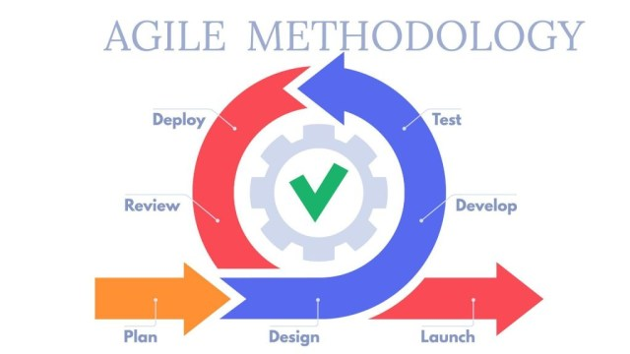

*Figure 1: Iterative Model.*

**Research Design**

The development of CLIRDEC: PRESENCE will adopt a developmental research design grounded in an iterative model. This approach enables continuous improvement of the system by incorporating feedback from real classroom scenarios. Each phase will be focusing on gradually refining core features such as RFID-based smart ID scanning, motion sensor validation, and automated attendance logging and alerts.

This design will ensure that the system remains responsive to user needs and institutional requirements throughout development. It will support practical testing in actual lecture and laboratory settings within the CLIRDEC building, which will allow the system to evolve in alignment with the workflow of professors, students, and administrators while minimizing operational disruptions.

**Planning Phase**

In the Planning phase, the developer will gather requirements and assess feasibility. Key features will be identified, including RFID-based Smart ID scanning, motion sensor-based presence validation, automatic schedule-based session activation, grace period handling, and email notifications to parents based on attendance behavior. Constraints such as hardware compatibility, budget limits, and institutional policies will be considered. Preliminary specifications will be drafted, covering required hardware (ESP32 microcontrollers, RFID readers, proximity sensors), software (Python, MySQL, web technologies), and defined user roles (administrators, professors, students). A high-level timeline and cost estimate will be created, and the selected tools and technologies will be validated to ensure alignment with CLSU’s infrastructure. This phase established the foundation for the system’s design and development.

**Requirements Gathering**

* The initial step involves gathering functional and technical requirements from CLIRDEC faculty and staff through interviews, consultations, and classroom observations.
* Key features identified include RFID integration, proximity sensor validation, dashboard interfaces, and automated attendance report generation.
* Questions:

For Faculty (Yes/No):

* + - * Do you believe the current manual attendance system contributes to ghost attendance?
      * Would you prefer a system that automatically records and reports attendance?
      * Do you think real-time dashboards can help you monitor attendance more efficiently?
      * Are you willing to use an RFID-based attendance system integrated with motion detection?
      * Do you find discrepancy alerts (e.g., tap without body detection) useful in verifying student presence?

For Students (Yes/No):

* Do you find the manual attendance process time-consuming or inconvenient?
* Are you willing to use your RFID ID to tap in and out of class sessions?
* Do you want to be able to view your own attendance logs online?
* Do you agree that using proximity sensors can prevent students from tapping in for others?
* Would a system that validates your physical presence encourage you to attend classes more regularly?

**Feasibility Study**

A feasibility study will be conducted to evaluate the project’s viability in three dimensions:

**Financial Feasibility**

The developer selected cost-effective, reliable components to ensure the feasibility and practicality of the CLIRDEC: PRESENCE system. The ESP32 microcontroller was chosen for its built-in Wi-Fi and Bluetooth capabilities, allowing real-time data transmission at a low cost. The RC522 RFID readers enable quick and accurate student identification during tap-in and tap-out processes, while the HC-SR04 ultrasonic proximity sensors provide additional physical validation to detect actual student presence, preventing ghost attendance. Power supply units and miscellaneous materials such as wires, LEDs, and resistors are essential for hardware integration and signaling. All software tools including Python, IDEs, and database systems are open-source, helping the developer minimize licensing expenses. Annual maintenance is budgeted to cover server hosting and potential hardware replacements. Overall, the selection of affordable and open-source tools supports both the financial feasibility and scalability of the system within an academic setting.

**Technical Feasibility**

The developer selected widely supported, affordable, and compatible technologies to ensure successful implementation. Python and MySQL were chosen for backend and data management due to their stability, extensive documentation, and compatibility with IoT projects. The ESP32 microcontroller was selected for its built-in Wi-Fi and ample input/output support, ideal for classroom deployment. Paired with RC522 RFID readers and proximity sensors, the hardware setup ensures accurate attendance tracking. The use of CLSU’s existing 13.56 MHz Smart ID cards also guarantees system compatibility. All tools are open-source, documented, and aligned with the development team’s skills, confirming strong technical feasibility, confirming the system is technically feasible with our team’s expertise.

**Operational Feasibility**

### The system is designed to seamlessly integrate with CLSU’s current academic operations, minimizing disruption while enhancing efficiency. It supports three key user roles Administrators, Professors, and Students each with clearly defined functions. Administrators manage schedules and monitor logs, while professors oversee session attendance. Students simply tap in and out using their existing CLSU Smart ID cards, eliminating the need for new learning curves. Attendance is evaluated automatically based on predefined rules and class timing, reducing manual oversight. The system is configured to run in two lecture and two lab rooms using consistent, low-maintenance hardware. Its alignment with CLSU’s structure and minimal user training needs confirm its operational feasibility.

**Design Phase**

## During the Design phase, the developer will define the system’s structural and functional blueprint. This includes creating block diagrams, flowcharts, and use-case diagrams to visualize how components like the ESP32 microcontroller, RFID reader, and proximity sensors interact with a central MySQL database and web-based dashboard. The data model will be carefully structured with tables for students, attendance logs, schedules, and computer assignments ensuring that real-time monitoring, rule-based validation (e.g., grace periods and late thresholds), and parent alert features are fully supported. Interface logic is also defined: tap-in starts at the scheduled class time, while tap-out activates only at session end, and all actions are recorded against system rules. These detailed designs will serve as the foundation for accurate implementation and testing in the next development phases.

## System Architecture/Conceptual Framework

## System Architecture

## The System Architecture Diagram presents an overview of what the core components of CLIRDEC: PRESENCE attendance monitoring system is all about, and how these core components are related in providing such functionality. From IoT hardware such as RFID readers and proximity sensors to the microcontroller (ESP32), all the way to a cloud database and a web-based dashboard, the flow has been outlined. The diagram describes the entry and exit points data capturing of student attendance, processing with microcontroller, and relaying for storage and retrieval in the back-end system setup. Such structural inspection becomes requisite in understanding how the system provides support for real-time attendance tracking, discrepancy validation, and automated reports within the CLIRDEC setting. Figure 2 presents this architectural layout in detail.

**Conceptual Framework**

This study adopts the Input-Process-Output (IPO) model to guide the design and development of the CLIRDEC: PRESENCE system. The model clearly outlines how data such as RFID taps, proximity detection, schedules, and room assignments are collected (Input), processed through validation and session logic (Process), and translated into useful outputs like real-time logs, reports, and alerts (Output). This structured framework ensures a clear, step-by-step approach in automating attendance, improving accuracy, and reducing manual workload. Using the IPO model allows the system to address specific attendance issues, such as ghost logging and delayed reporting, through real-time processing and smart validation.

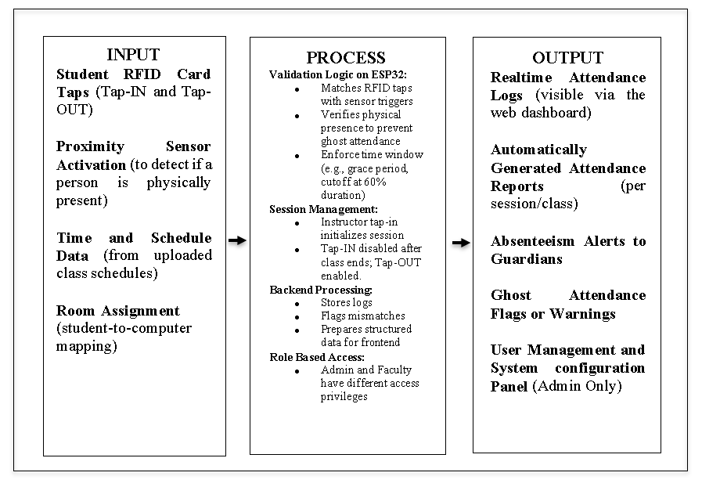

*Figure 3: Conceptual Framework.*

**The Entity Relationship Diagram (ERD)**

The Entity Relationship Diagram (ERD) outlines the underlying structure of the CLIRDEC: PRESENCE system, ensuring reliable and consistent data handling throughout attendance tracking operations. The developer used the ERD to map out how data flows between users, classroom activities, and the system’s automated validations and alerts. By organizing relationships clearly, the ERD will help the developer create a functional, scalable, and error-resistant database. It will also ensure that each process from student tap-ins to discrepancy detection and notifications can be implemented smoothly, reinforcing the integrity and accountability of the attendance monitoring system.

**Flowchart**

The flowchart serves as a visual guide to the logical operation of the CLIRDEC: PRESENCE system. It illustrates how the system processes RFID taps, detects student presence via sensors, and logs entry and exit actions within a classroom session. This structured diagram helps the developer visualize the sequence of actions and decisions made by the system, from activation to validation and reporting. It ensures that all functions align with expected behaviors and enables smoother debugging, testing, and optimization during development.

**Use-Case Diagram**

This diagram illustrates the core functionalities of the CLIRDEC: PRESENCE system and its three user roles: administrator, faculty, and student. Administrators manage users, schedules, and monitor attendance with discrepancy checks. Faculty access dashboards, review logs, and generate reports. Students tap their RFID IDs for entry/exit, validated by proximity sensors and schedules. The system automates logging and sends alerts for absences or discrepancies to parents.

**Development Phase**

In the development phase, the developer will construct the system based on the approved design. The ESP32 microcontrollers will be programmed to interface with RFID readers and proximity sensors installed in each classroom. These devices will detect student tap-ins and physical presence at the appropriate times, based on the system’s synchronized class schedule. Tap-in will be enabled at the start time of each scheduled class, with a 15-minute grace period. Tap-outs will be enabled only after the class has officially ended. Backend logic will be implemented using Python with a MySQL database to manage attendance logs, class schedules, computer assignments, and student records. The web-based dashboard will be developed using HTML, CSS, JavaScript, and Bootstrap for the frontend. Visual Studio Code will be used as the primary development environment.

During this phase, modular components will be developed incrementally—starting with basic attendance logging, followed by proximity validation, schedule enforcement, and the email alert feature for absences or behavioral flags. Email scripts will be configured to send automatic notifications to the parent or guardian if a student is marked absent. Each function will be tested in real-world conditions to ensure correct operation as the implementation progresses.

**Development**

* The development phase will involve building the backend using Python (via FastAPI) for API logic and hardware integration, and the frontend using TypeScript, React, and Vite. Tailwind CSS and Shadcn/ui will be used for the interface, with Express.js as an optional backend alternative.
* Development will follow an iterative model, where each cycle includes feature implementation, debugging, and refinement based on ongoing feedback from CLIRDEC faculty and stakeholders.
* The system will be configured in a test environment with PostgreSQL as the main database, hosted via Neon and managed using Drizzle ORM (TypeScript) and SQLAlchemy (Python).
* Integration of hardware components such as ESP32 microcontrollers, RFID readers, and proximity sensors will also be carried out. Final validation will involve pilot deployment in selected CLIRDEC classrooms to assess readiness for full-scale implementation.
* Final validations will be conducted with faculty to identify deployment issues and confirm system readiness for broader use.

**Development Tools and Technologies**

The development of the CLIRDEC: PRESENCE – Proximity and RFID-Enabled Smart Entry for Notation of Classroom Engagement will utilize both hardware interfacing and software implementation tools and technologies to support automated attendance tracking and real-time monitoring:

* **Programming Languages:** During system development, the project will primarily use TypeScript for frontend and backend, with Python for API and hardware integration, alongside JavaScript, SQL, and CSS for styling.
* **Frameworks:** FastAPI will be used for the Python backend, while React with Vite will handle the frontend. Tailwind CSS and Shadcn/ui will be used for UI, with Express.js as an optional backend implementation.
* **Database:** PostgreSQL will serve as the main relational database, managed using Drizzle ORM for TypeScript and SQLAlchemy for Python-based operations.
* **Development Tool:** Visual Studio Code will act as a primary integrated development environment (IDE) to write and organize system code.
* **Hardware:** Use of ESP32 microcontroller (otherwise Arduino Uno), RFID readers, RFID cards, and proximity sensors presenting any kind (like PIR sensors).

**Algorithms and Techniques**

The CLIRDEC: PRESENCE - Proximity and RFID-Enabled Smart Entry for Notation of Classroom Engagement will utilize the following algorithms and techniques to ensure accurate attendance tracking and anomaly detection:

* + **RFID-Based Logging:** This method will capture at each entry and exit of the students with this method will read RFID card data and associates it with the specific session time when that card event occurred.
  + **Proximity Validation:** An actual presence will be detected via motion or infrared sensor during an RFID tap for a student entering or exiting the room so as to prevent ghost attendance.
  + **Discrepancy Detection Algorithm:** Will compare RFID logs with sensor body counts. If a student taps their RFID but no physical body is detected or if the sensor detects a body with no corresponding RFID tap the system will flag a discrepancy for faculty and administrator review.
  + **Time Window Validation:** Will validates the log for tap-in and tap-out within the time assigned for that session, thus eliminating early or late unauthorized entry marking as valid attendance.
  + **Data Integrity Checks:** Verifies that RFID inputs, timestamps, and sensor logs are complete and correctly formatted before being stored in the database.

**Test Phase**

In the Testing phase, each functional component of the system will be validated against the defined requirements. Functional tests will confirm that RFID scanning, proximity detection, class schedule enforcement, and email notifications operate correctly. Simulated classroom scenarios in both lecture halls and laboratories will be used to observe system behavior during real-time attendance tracking. Unit tests will assess the accuracy of time-based logic—ensuring students tapping within the schedule are marked Present, those within the grace period as Late, and taps beyond 60% of the session duration as Absent. Email alerts for absences will also be verified to ensure they are sent to the correct parent or guardian addresses. Additionally, stress testing will evaluate system reliability under high usage, such as multiple concurrent taps.

All test outcomes, including defects, will be documented and resolved. Each fix will be retested to confirm stability and data accuracy. This phase ensures the system functions as intended and is ready for deployment in the CLIRDEC environment.

**Testing**

* This will be the stage where multiple levels of testing will be employed such as testing units on the backend functions for attendance logging and sensor triggers, integration tests on interactions with the database, and functional tests on dashboard modules.
* Usability testing will be also conducted with faculties to assess system responsiveness, accuracy, and user-friendliness.

**Table 1:** Test Cases

|  |  |
| --- | --- |
| **Fields** | **Description** |
| Test Case ID | Unique identifier for the test case |
| Test Case Description: | Brief description of the test case’s purpose |
| Pre-conditions | List of conditions before executing the test case |
| Test Steps | List of actions to be performed during the test. |
| Test Data | Input data values required to execute the test case. |
| Expected Result | The anticipated outcome based on the test inputs and conditions. |
| Post Condition | The state of the system after executing the test. |
| Actual Result | The outcome observed after performing the test steps. |
| Status | Indicates whether the test case passed or failed. |
| Project Name | The title of the project under which the test is conducted. |
| Module Name | The specific module or component being tested. |
| Reference Document | Related documents or specifications that support the test case. |
| Created By | Name of individual who created the test case. |
| Date of Creation | The date when the test case was written. |
| Reviewed By | Name of the person who reviewed and validated the test case. |
| Date of Review | The date when the test case was reviewed. |
| Executed By | The person who performed the test case execution. |
| Date of Execution | The actual date the test was executed. |
| Comments | Additional remarks encountered during testing. |

**Data Collection and Processing**

The CLIRDEC: PRESENCE system will involve data collection and processing to monitor student attendance, validate physical presence, and generate accurate reports for classroom sessions in real time.

**Data Sources:**

* **RFID Tap Logs:** The system will collect data from each student’s RFID tap-in and tap-out activity, capturing student ID, timestamp, and classroom/session ID.
* **Sensor Logs:** Proximity or motion sensors placed at classroom entry and exit points detect actual movement, providing presence validation to confirm that each tap corresponds to a real person entering or exiting.
* **Session Schedules:** Faculty-defined schedules and session data will be stored in the system to determine whether student entry/exit occurred within the valid time window.

**Data Processing:**

* Tap events will be matched with sensor data to validate physical presence.
* Attendance status will be determined by evaluating RFID logs and session timing: students will be tagged as Present, Late, or Absent accordingly.
* Discrepancies will be automatically flagged when mismatches occur between RFID and sensor data (e.g., a tap with no physical body detected or vice versa).
* Aggregated attendance records will be compiled to generate class attendance summaries, individual student logs, and irregularity reports.

**Statistical Treatment:**

* Descriptive Statistics: Adopted in elaborating with attendance data per session, i.e., number of students marked Present, Late, or Absent.
* Comparative Analysis: Evaluates attendance accuracy and faculty reporting efficiency before and after implementing CLIRDEC: PRESENCE to measure improvements in monitoring and automation.
* Trend Analysis: Identifies patterns in absenteeism, entry/exit behavior, and sensor discrepancies across time periods to inform faculty interventions and improve attendance policies.

**Evaluation**

The reliability, usability, and effectiveness of the CLIRDEC: PRESENCE - Proximity and RFID-Enabled Smart Entry for Notation of Classroom Engagement will be ensured through a comprehensive testing process conducted throughout the project’s development cycle. The system will be evaluated directly by its intended users faculty members and students from the CLIRDEC department through simulated class sessions and actual pilot runs. Feedback from professors will be gathered to assess system usability, accuracy, and convenience in monitoring attendance, while students will evaluate the ease of use and responsiveness of the RFID tap mechanism. Their insights will help identify usability issues, guide improvements, and ensure the system meets the practical needs of its users in real classroom settings.

**Testing Strategies:**

* **Unit Testing:** Each system component such as RFID tap detection, proximity sensor input, session activation, and timestamp recording will be individually tested to verify correct functionality, accuracy, and responsiveness.
* **Integration Testing:** The integration between hardware and software modules (e.g., RFID + proximity sensor + database logging) will be tested to ensure data consistency across components and proper communication between the frontend dashboard and backend storage.
* **Usability Testing:** Faculty members and selected CLIRDEC students will be engaged to evaluate the system interface and overall experience. These sessions will help determine the system’s usability, efficiency in logging attendance, and ease of generating reports.

**Evaluation Models**

**ISO Standards**

Evaluation with respect to international software quality guidelines will be based on the ISO/IEC 25010 standard, which defines the quality model for software systems. Specifically, the CLIRDEC: PRESENCE system will be assessed under the following quality characteristics: functional suitability, usability, reliability, and performance efficiency. These ISO/IEC 25010 benchmarks ensure that the system meets accepted global standards for quality and effectiveness in academic environments, supporting reliable deployment and user satisfaction.

**Ethical Considerations**

The development and deployment of the CLIRDEC: PRESENCE system will strictly adhere to ethical standards, including compliance with the CLSU Data Privacy Policy and Republic Act No. 10173, or the Data Privacy Act of 2012. Informed consent will be obtained before collecting any user feedback or test data, and only anonymized or simulated student information will be used during the development and testing phases to protect personal privacy. Usability testing will involve brief feedback forms and direct observation to gather insights from faculty, focusing on interface clarity, responsiveness, and ease of use. All attendance data will be securely transmitted using encrypted protocols, and access to sensitive records will be limited to authorized personnel only. Data collected will be strictly used for academic attendance monitoring and reporting purposes, with transparency and accountability emphasized in all stages of system use.

**Review & Refinement Phase**

In the Review and Refinement phase, the developer assessed the outcome of each development cycle based on performance, accuracy, and stakeholder feedback. After deploying a test build of the system in controlled classroom settings, usability feedback will be gathered from CLIRDEC faculty and selected users. Early testing revealed issues such as sensor misalignment and incorrect time validations, which will be addressed through hardware repositioning and logic adjustments in the code. User feedback also highlighted areas for improving alert accuracy and user interface clarity. For instance, adjustments will be made to the email alert mechanism to ensure notifications will be sent only when a student failed to tap within the allowed schedule range, and redundant alerts will be eliminated. Additionally, real-time dashboard elements will be fine-tuned for readability and responsiveness.

Each refinement cycle ensured that the system increasingly aligned with real-world use cases and institutional requirements. By the final iteration, the system will be capable of automatically starting and stopping class sessions based on uploaded schedules, accurately categorizing attendance based on timing, and reliably notifying guardians of student absences.

**Events:**

* Iteration Cycle: Each development cycle focuses on implementing and refining specific features such as RFID logging, dashboard integration, or discrepancy detection. These cycles allow the system to be gradually improved based on functional objectives.
* Iteration Planning: At the beginning of each cycle, the development plan is reviewed and refined based on updated requirements and stakeholder feedback. Tasks will be organized to align with project goals and technical feasibility.
* Progress Monitoring: During development, regular progress checks will be conducted to assess development milestones, address technical challenges, and ensure the iteration stays on track.
* Feature Review: At the end of each cycle, completed features will be reviewed with the CLIRDEC coordinator and selected faculty members. Their feedback is recorded for further refinement in the next iteration.
* Iteration Reflection: After each cycle, the development process is evaluated to identify areas of success and aspects needing improvement. Adjustments will be made in preparation for the next iteration to enhance the system's functionality and usability.

APPENDICES

**Appendix A**

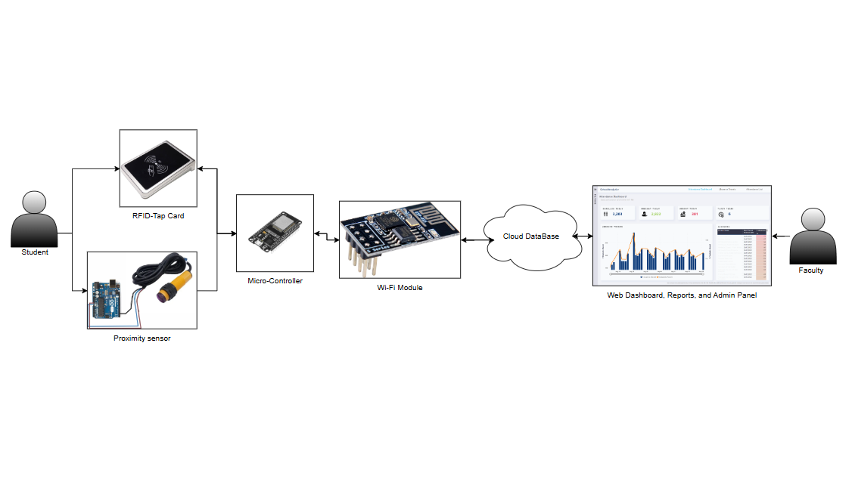

*Figure 2: System Architecture Diagram*

**Appendix A**

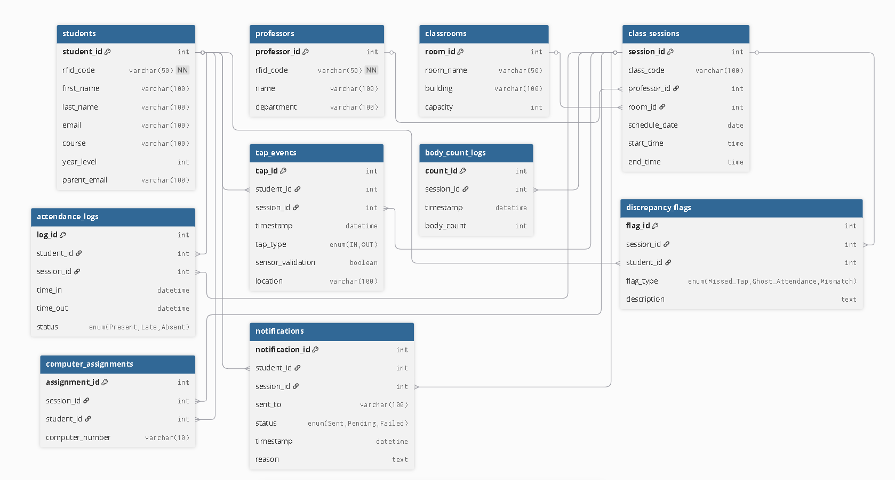

*Figure 4: Entity Related Diagram*

**Appendix A**

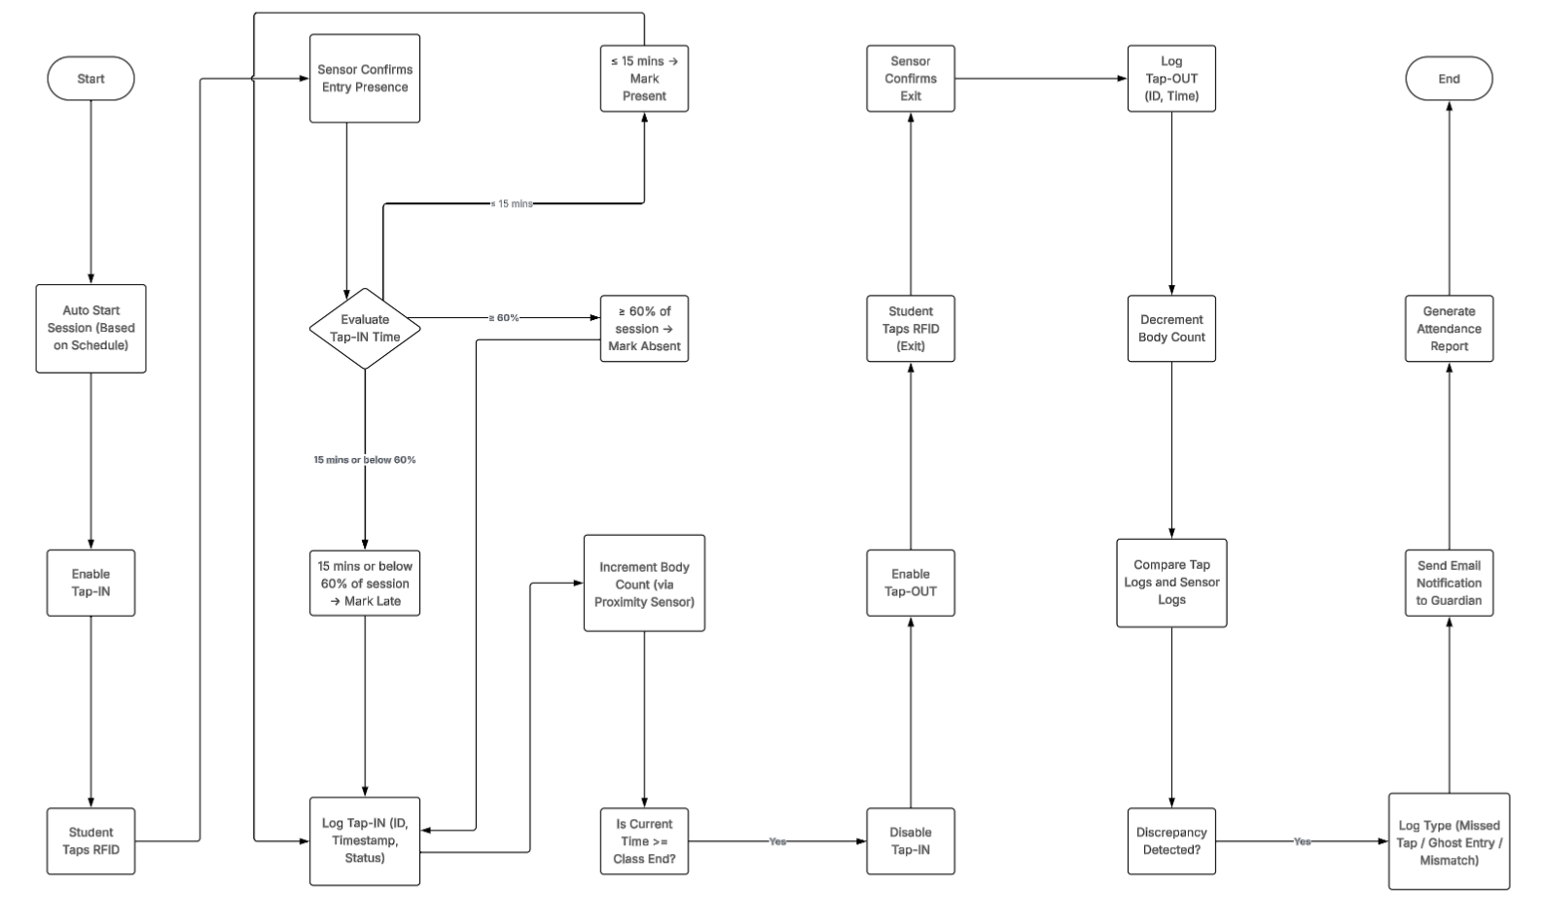

*Figure 5: Flowchart*

**Appendix A**

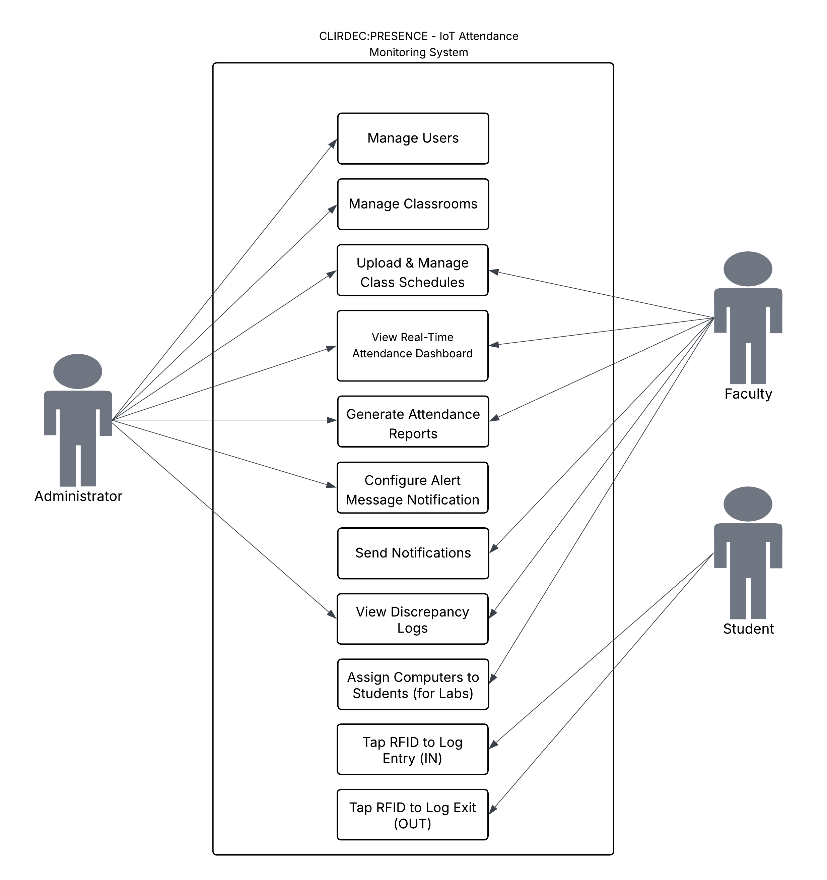

*Figure 6: Use-Case Diagram*

**Appendix B**

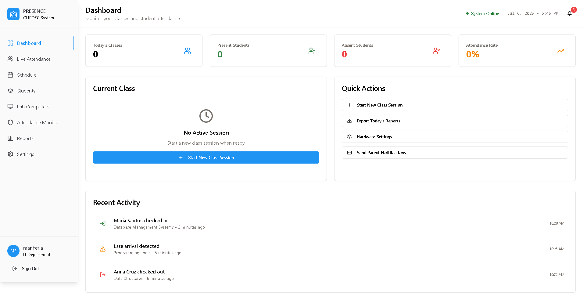

*Figure 6: PRESENCE Dashboard*

**Appendix B**

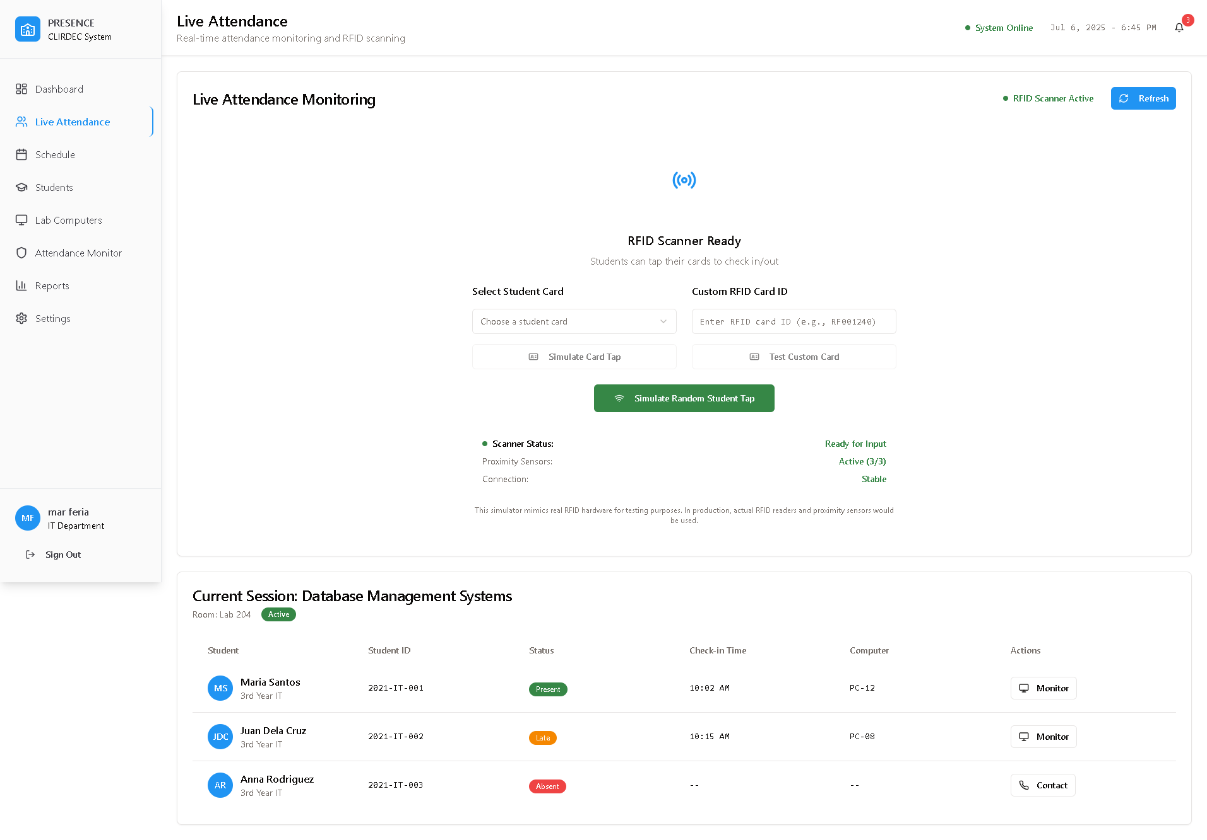

*Figure 7: PRESENCE Live Attendance*

**Appendix B**

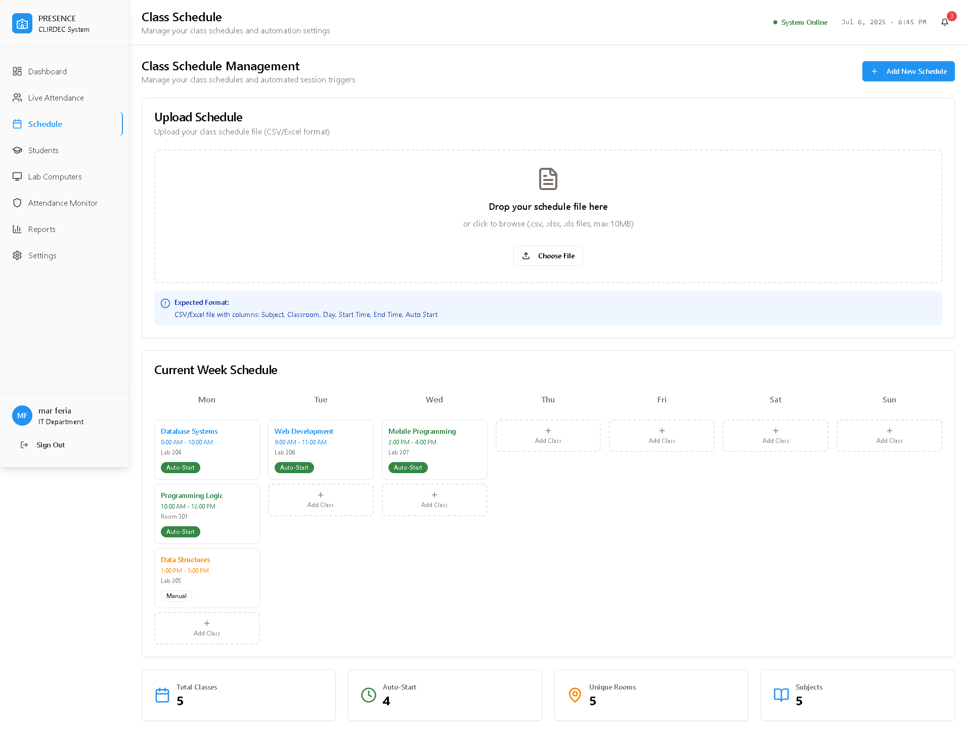

*Figure 8: PRESENCE Class Schedule*

**Appendix B**

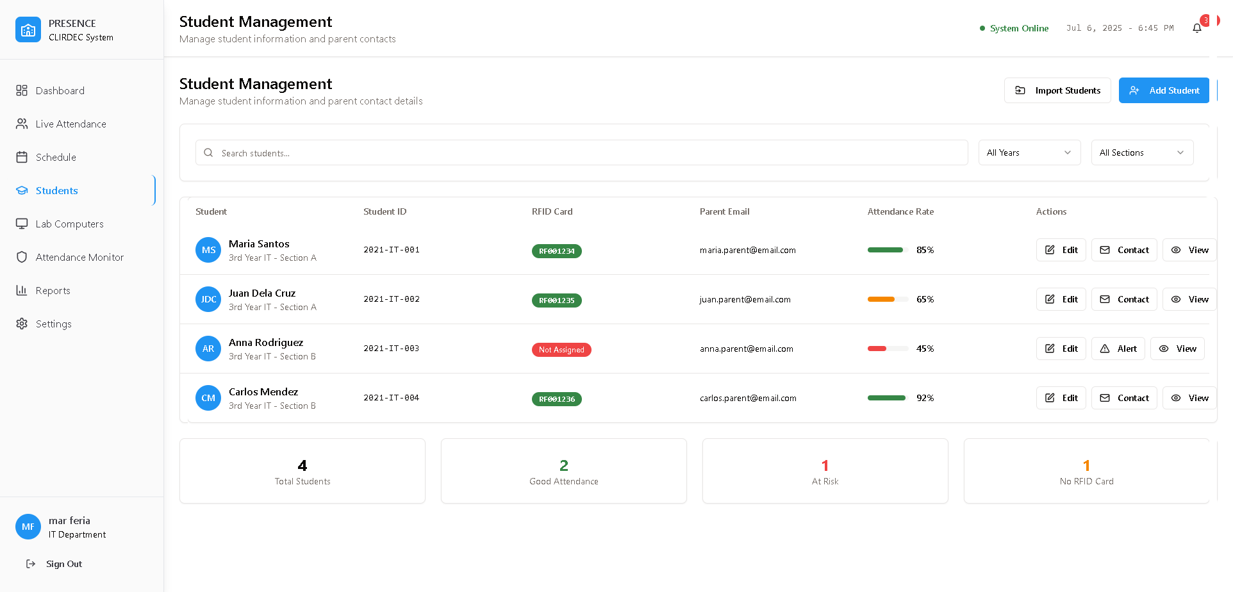

*Figure 9: PRESENCE RFID Students Management*

**Appendix B**

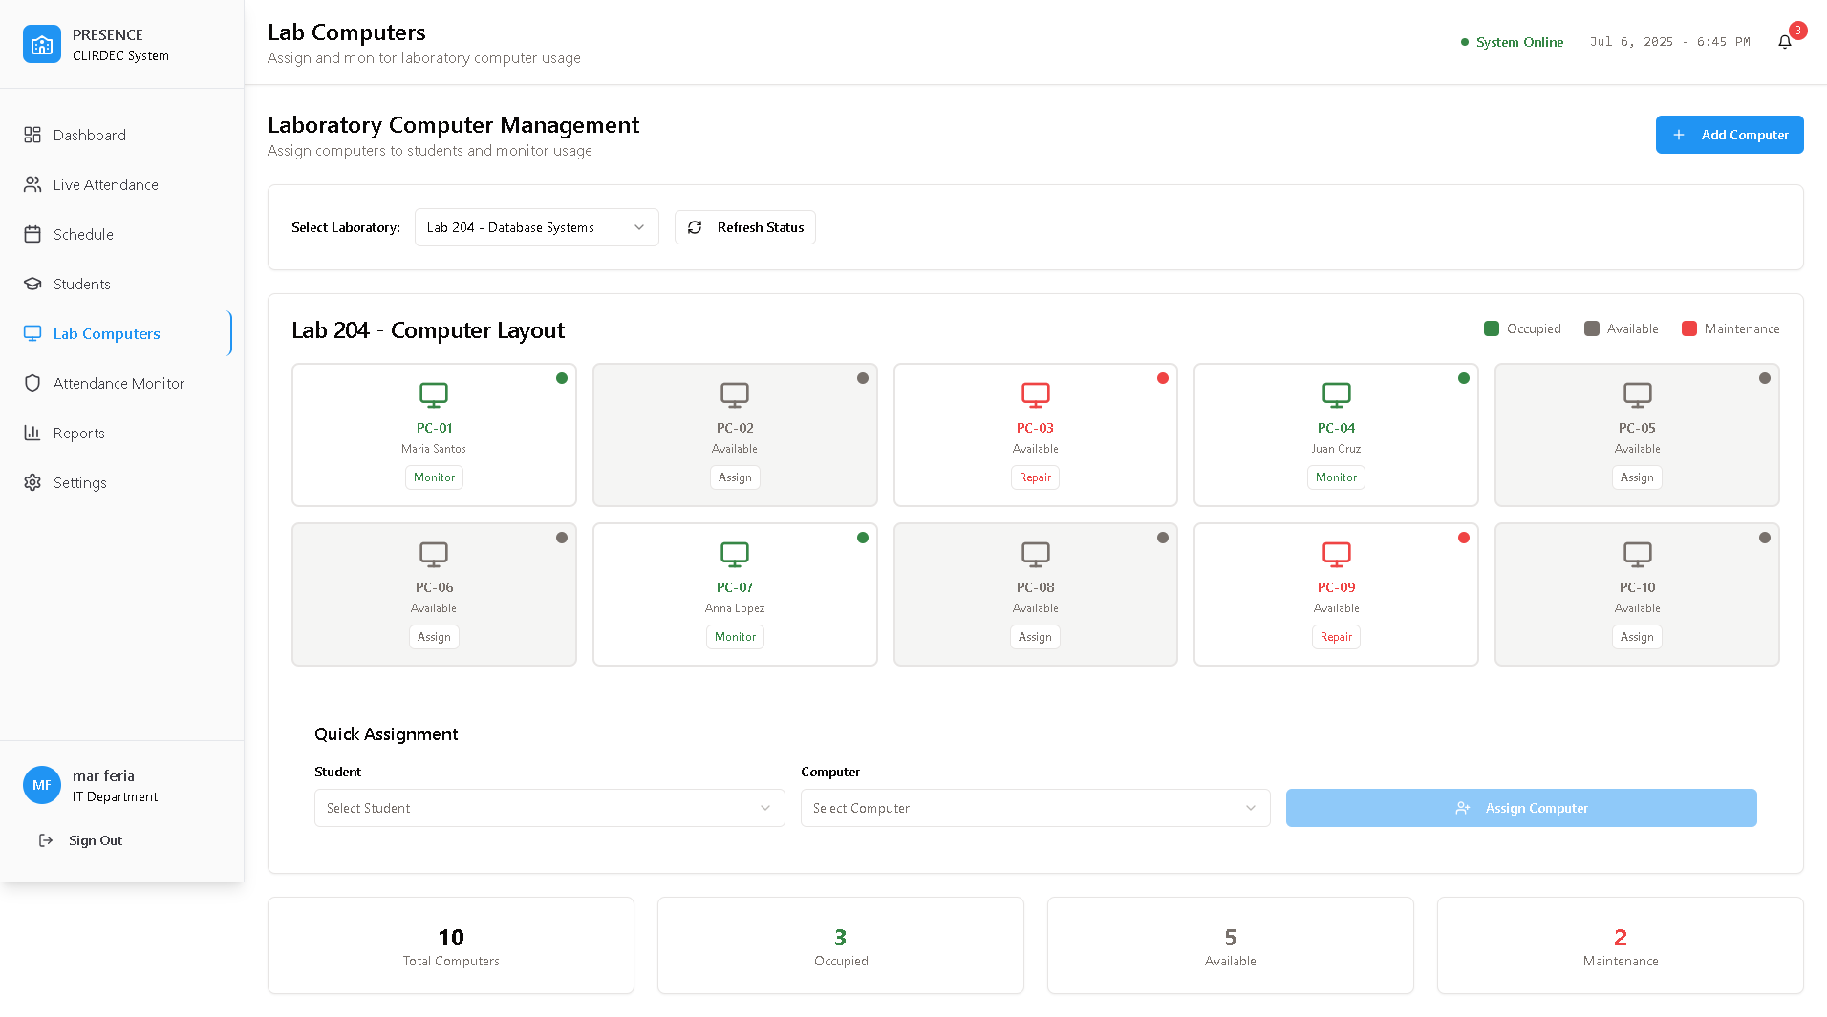

*Figure 10: PRESENCE Computer Management*

**Appendix B**

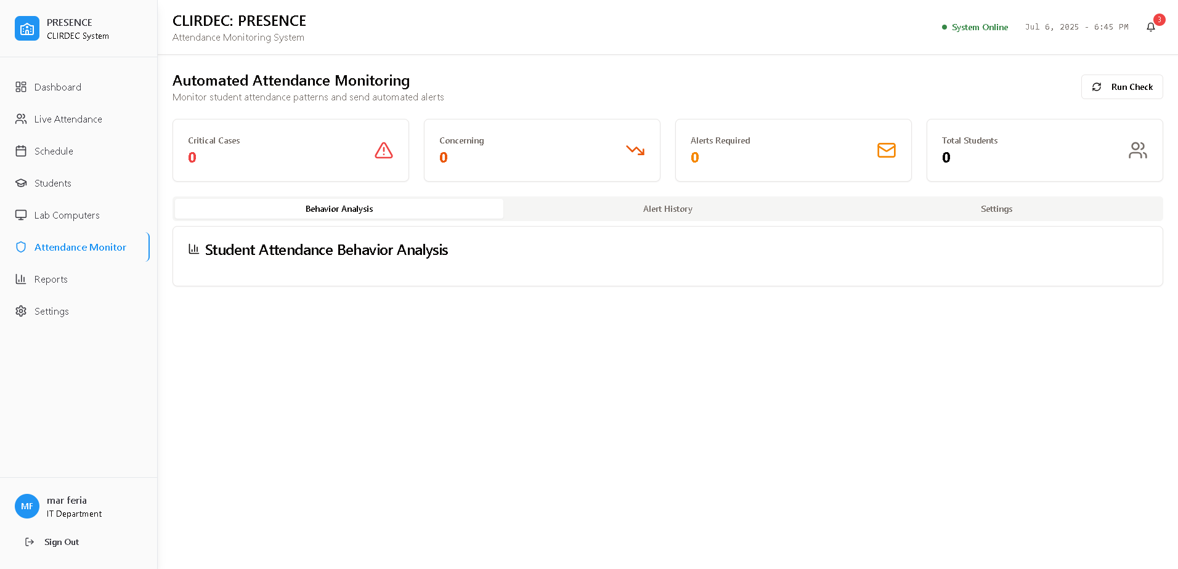

*Figure 11: PRESENCE Attendance Monitor*

**Appendix B**

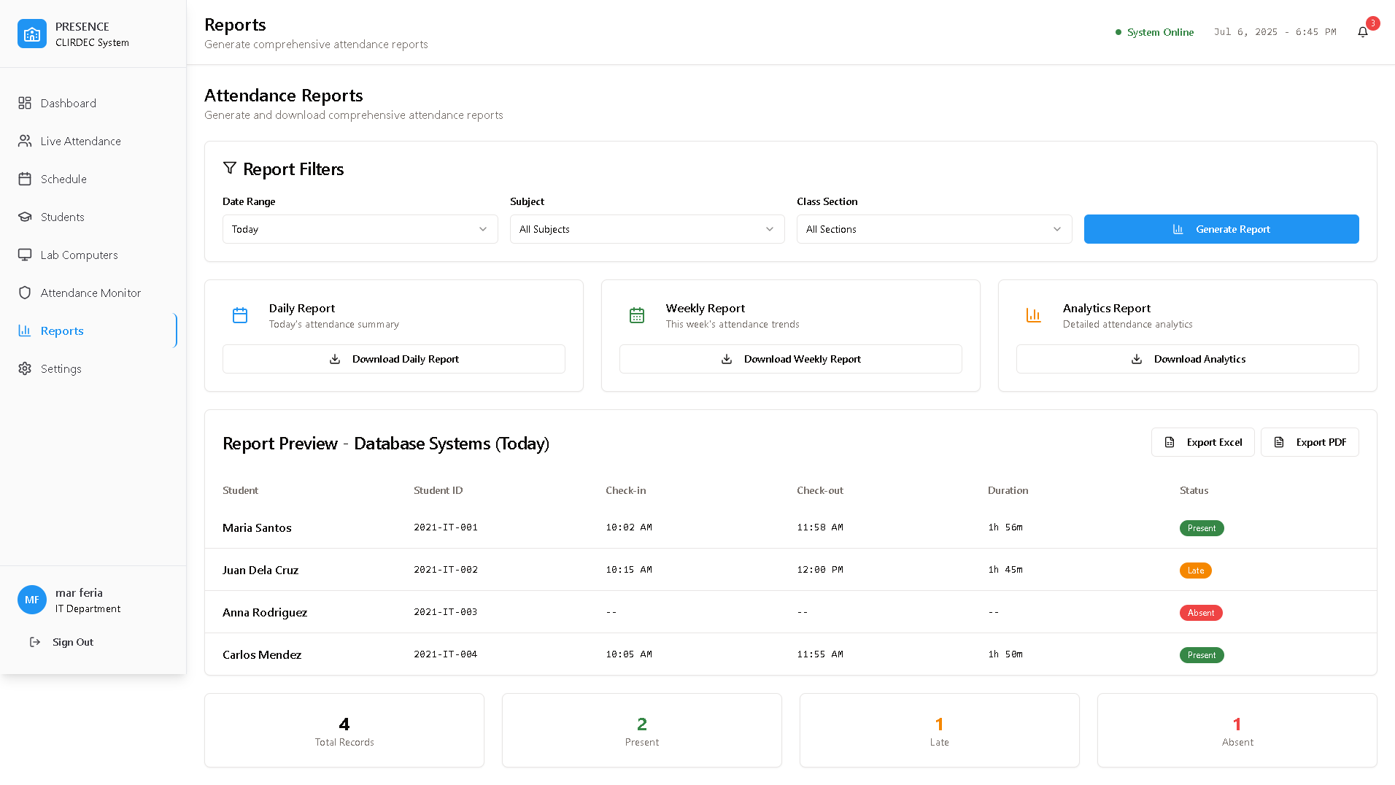

*Figure 12: PRESENCE Reports Analytics*

**Appendix B**

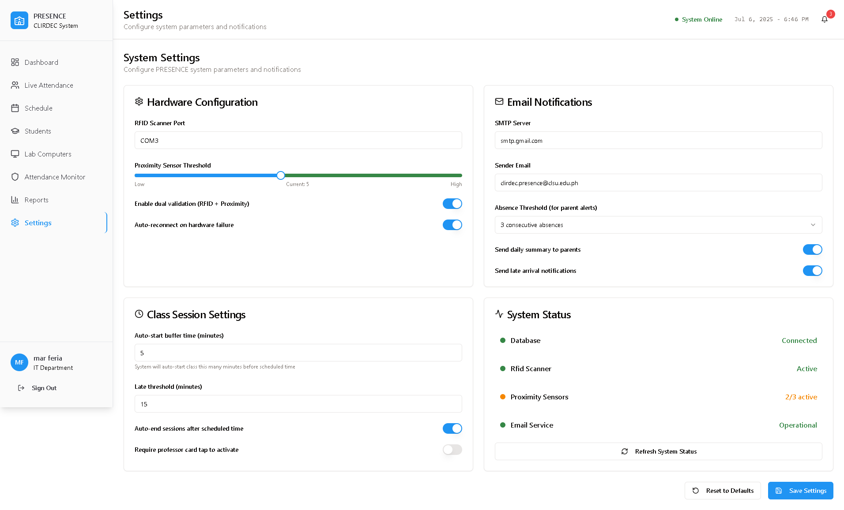

*Figure 12: PRESENCE Settings*

**Appendix B**

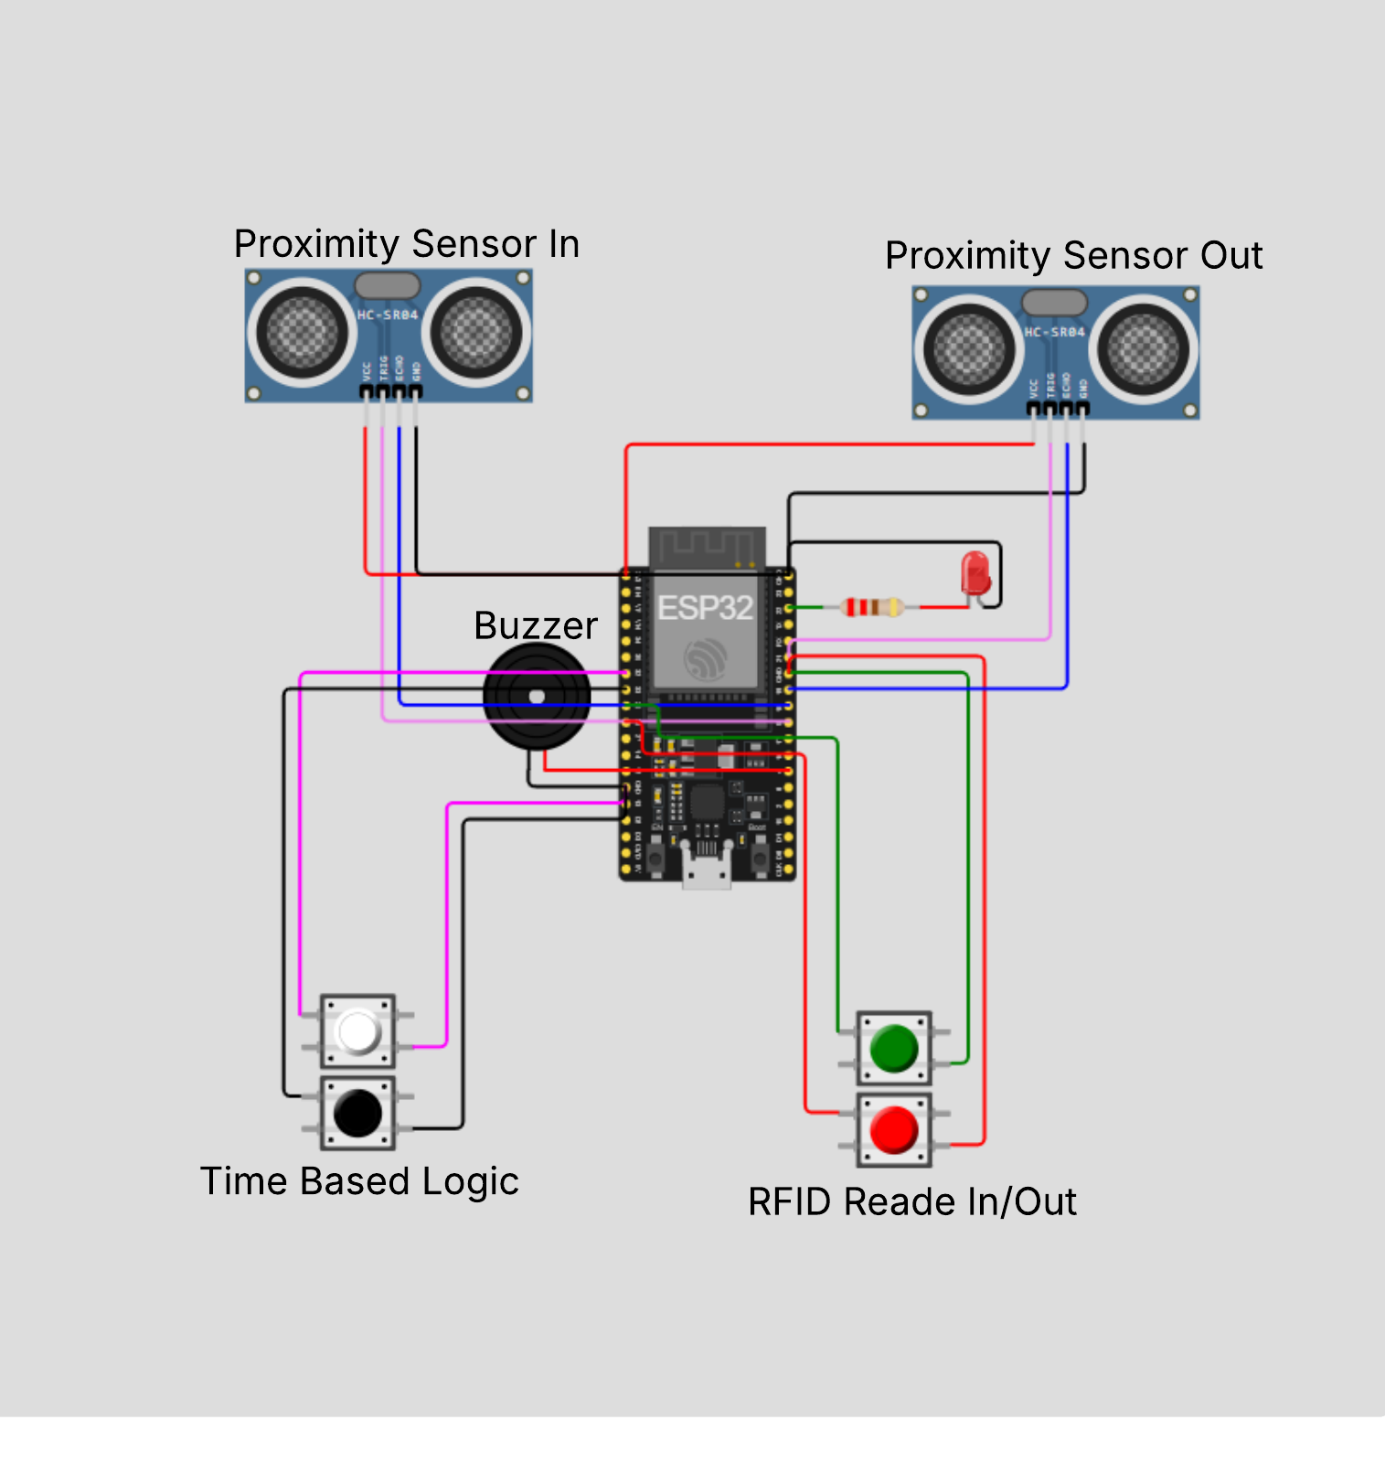

*Figure 13: PRESENCE IoT-Device*

References

Ahmed, S., & Mazri, T. (2023). Security approaches for smart campus. In *Lecture notes in networks and systems* (pp. 196–205). <https://doi.org/10.1007/978-3-031-26852-6_18>

Mylonas, G., Amaxilatis, D., Tsampas, S., Pocero, L., & Gunneriusson, J. (2019). A Methodology for Saving Energy in Educational Buildings Using an IoT Infrastructure. *2019 10th International Conference on Information, Intelligence, Systems and Applications (IISA)*, 1–7. <https://doi.org/10.1109/iisa.2019.8900707>

Nguyen, V. D., Van Khoa, H., Kieu, T. N., & Huh, E. (2022b). Internet of Things-Based Intelligent Attendance System: Framework, practice implementation, and Application. *Electronics*, *11*(19), 3151. <https://doi.org/10.3390/electronics11193151>

Samaddar, R., Ghosh, A., Sarkar, S. D., Das, M., & Chakrabarty, A. (2023). IoT & Cloud-based Smart Attendance Management System using RFID. *International Research Journal on Advanced Science Hub*, *5*(03), 111–118. <https://doi.org/10.47392/irjash.2023.020>

Zhao, M., Zhao, G., & Qu, M. (2022). College Smart Classroom attendance Management system based on Internet of things. *Computational Intelligence and Neuroscience*, *2022*, 1–9. <https://doi.org/10.1155/2022/4953721>

Krihsna, P. G., Subbarayudu, Y., Rao, K. M., Jyoshna, V., Aman, J., & Reddy, G. V. (2023). An Efficient, Novel, and Sustainable IoT-Based Approach for Attendance Detection through RFID Module and IR Sensor. E3S Web of Conferences, 430, 01096. <https://doi.org/10.1051/e3sconf/202343001096>

Hayati, N., & Nugraha, A. E. (2023). Design and implementation proximity based IoT for smart attendance System. *Buletin Pos Dan Telekomunikasi*, *21*(2), 16–31. <https://doi.org/10.17933/bpostel.v21i2.380>

Hussien, S. H. T., Farhana, H. a. R. N., Vinukumar, L., Alexander, C. H. C., & Sivakumar, S. (2024). Smart campus attendance and security systems: Leveraging IoT for enhanced efficiency. *AIP Conference Proceedings*, *3161*, 020153. <https://doi.org/10.1063/5.0229386>

Ishaq, K., & Bibi, S. (2023). IoT Based Smart Attendance System Using RFID: A Systematic Literature Review. *arXiv (Cornell University)*. <https://doi.org/10.48550/arxiv.2308.02591>

Valdez, C. J. H., Nivales, Y. M., Uy, R. J. R., & Montañez, J. J. F. (2024). TrackID: RFID-Based student monitoring system for accessing institutional campus. *2021 International Conference on Innovation and Intelligence for Informatics, Computing, and Technologies (3ICT)*, 427–434. <https://doi.org/10.1109/3ict64318.2024.10824565>

Shoewu, N. O. O., Akinyemi, N. L. A., Mumuni, N. Q. A., Ajasa, N. a. A., Folorunso, N. C. O., & Edozie, N. R. (2022). Development of a smart attendance system using near field communication (SMAT-NFC). *Global Journal of Engineering and Technology Advances*, *12*(2), 121–139. <https://doi.org/10.30574/gjeta.2022.12.2.0150>

Verma, S. S., Vargiya, P. V., Sharma, P., & Kumar, R. (2022). RFID based attendance marker. Poornima College of Engineering, Department of Electrical Engineering. Retrieved from <https://pce.poornima.org/NAAC/Re-DVV/1/1.3.2/1.3.2.5/1.3.2.5.4_EeneE/G-20%20RFID%20Based%20Attendance%20Marker.pdf>

Abellana, L. K. B., Amper, B. P., Bacol, D. M. P., & Carias, A. M. G. (2022). RFID attendance system for students using Arduino with GSM. Bohol Island State University, College of Engineering, Architecture, and Industrial Design. <https://doi.org/10.13140/RG.2.2.17639.97446>

Velasco, R. M. (2023). IoT security solutions for students’ laboratory with RFID-based attendance authentication. *Journal Name*, *5*, 23–32.

Cadungog, R. R., Nambong, R. L., Hontiveros, N. L., Tenebroso, M. B. C., & Serrano, M. R. (2024). Cite_Stema SA Atendansiya: Modernizing Cite Students Attendance System with RFID Technology. *International Journal of Computer Science & Engineering Survey*, *15*(2/3/4), 01–16. <https://doi.org/10.5121/ijcses.2024.15401>

Yumang, A. N., Padilla, D., Sejera, M., Pajarillo, A. C. U., Van Laurent B Palmiano, G., & Racho, M. M. F. (2017). Attendance checker for students of Mapúa University. *2021 IEEE 13th International Conference on Humanoid, Nanotechnology, Information Technology, Communication and Control, Environment, and Management (HNICEM)*, 1–3. <https://doi.org/10.1109/hnicem.2017.8269558>

Grefaldo, L. H., Jr., & Bausa, M. E. (2025). Attendance monitoring and records management system for Pilar National Comprehensive High School using face recognition. Global Scientific Journal, 13(2), 23–32. [https://www.globalscientificjournal.com/researchpaper/ATTENDANCE_MONITORING_AND_RECORDS_MANAGEMENT_SYSTEM_FOR_PILAR_NATIONAL_COMP COMPREHENSIVE_HIGH_SCHOOL_USING_FACE_RECOGNITION.pdf](https://www.globalscientificjournal.com/researchpaper/ATTENDANCE_MONITORING_AND_RECORDS_MANAGEMENT_SYSTEM_FOR_PILAR_NATIONAL_COMP%20COMPREHENSIVE_HIGH_SCHOOL_USING_FACE_RECOGNITION.pdf)

Bayani, A. D. D., Fabra, M. G., Joseph, V. M. C., Pelayo, C. J. A., Diloy, M. A., & Esberto, E. M. (2023). WeConnect: Class attendance monitoring system with the use of mobile tethering. In *Proceedings of the 2023 8th International Conference on Information and Education Innovations (ICIEI '23)* (pp. 126–129). Association for Computing Machinery. <https://doi.org/10.1145/3594441.3594462>

Saint Louis University. (n.d.). Privacy policy – Data Protection Office. <https://dataprotection.slu.edu.ph/privacy-policy-2/>